Amazon | OA 2020 | Chemical Delivery System

## **Amazon OA - Choose A Flask**

LEET CODE : <https://leetcode.com/discuss/interview-question/893279/>

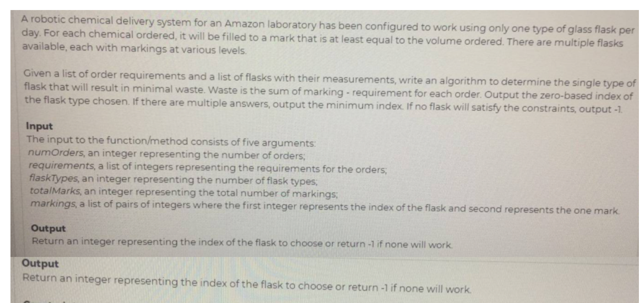

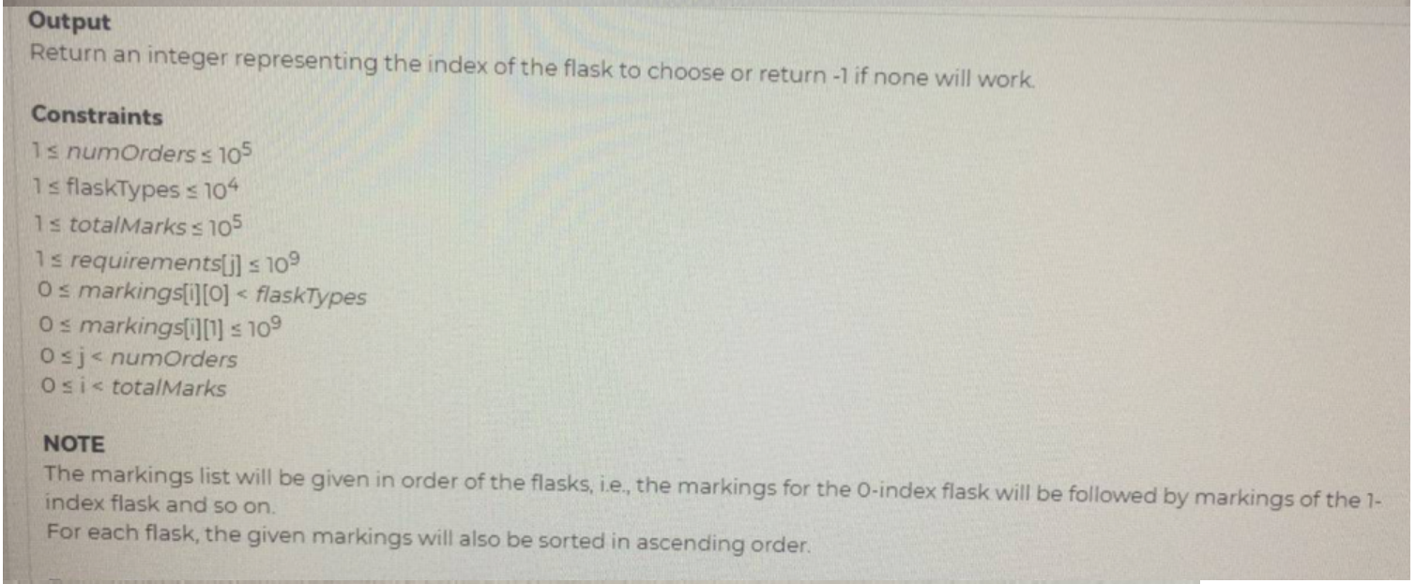

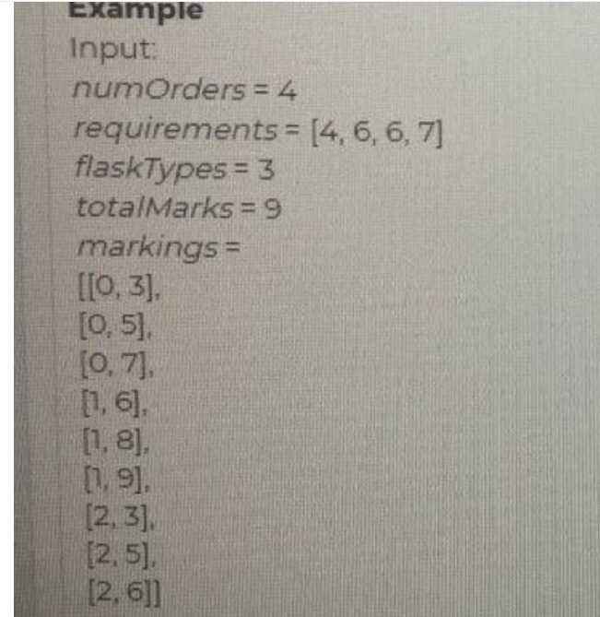

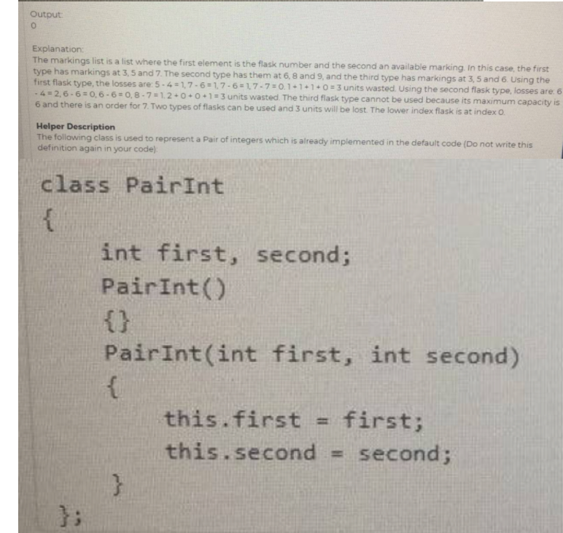

public static int chooseFlask(int numOrders, List<Integer> requirements,

int flaskTypes, int totalMarks, List<PairInt> markingsList) {

List<Integer>[] markings = groupMarkings(flaskTypes, markingsList);

int minWaste = Integer.MAX_VALUE;

int flask = -1;

for (int type = 0; type < flaskTypes; type++) {

int waste = getWaste(requirements, markings[type]);

if (waste < minWaste) {

minWaste = waste;

flask = type;

}

}

return flask;

}

private static List<Integer>[] groupMarkings(int flaskTypes, List<PairInt> markingsList) {

List<Integer>[] markings = new List[flaskTypes];

Arrays.setAll(markings, (i) -> new ArrayList<>());

for (PairInt marking : markingsList) {

markings[marking.first].add(marking.second);

}

return markings;

}

private static int getWaste(List<Integer> requirements, List<Integer> markings) {

int waste = 0;

int i = 0;

for (Integer req : requirements) {

while (i < markings.size() && markings.get(i) < req) i++;

if (i >= markings.size()) return Integer.MAX_VALUE;

waste += markings.get(i) - req;

}

return waste;

}